Tests EVA + P2D2-1 from PCOD

PCOD installed as « add user database » (green icon in the toolbox)
The “MASTER” file is PDF2

1- Correct formulation, less than 1% difference in cell parameters
τ-AlF₃ a = 10.184 c = 7.174
Prédiction 10.216 7.241
Difference (%) 0.31 0.93

Global search (Master + PCOD, chemistry not imposed) :
The real compound is found in first position, the predicted en 2nd position.

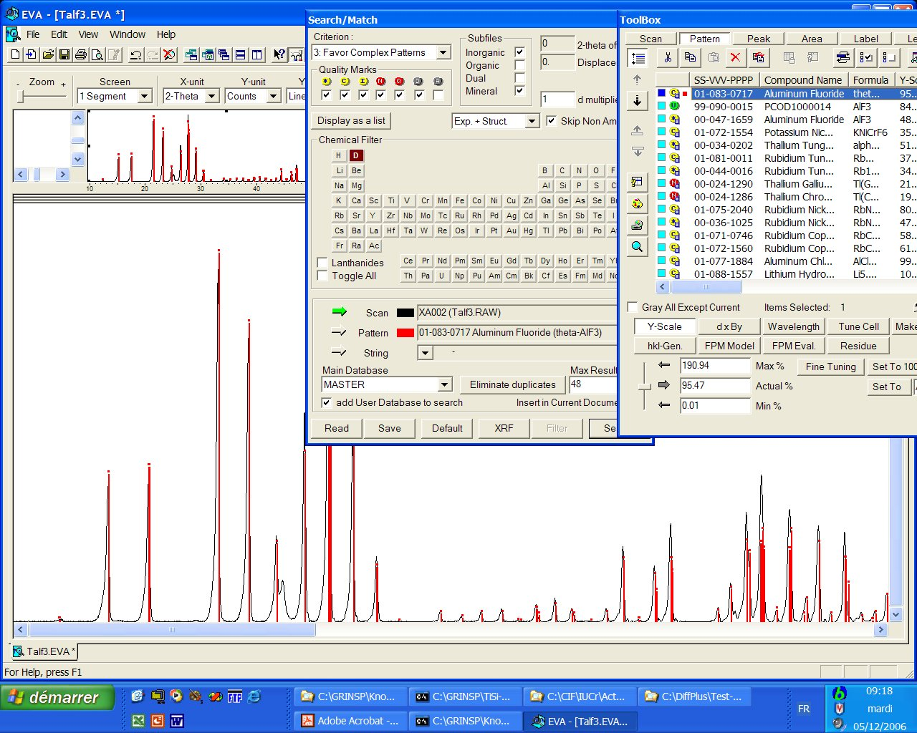

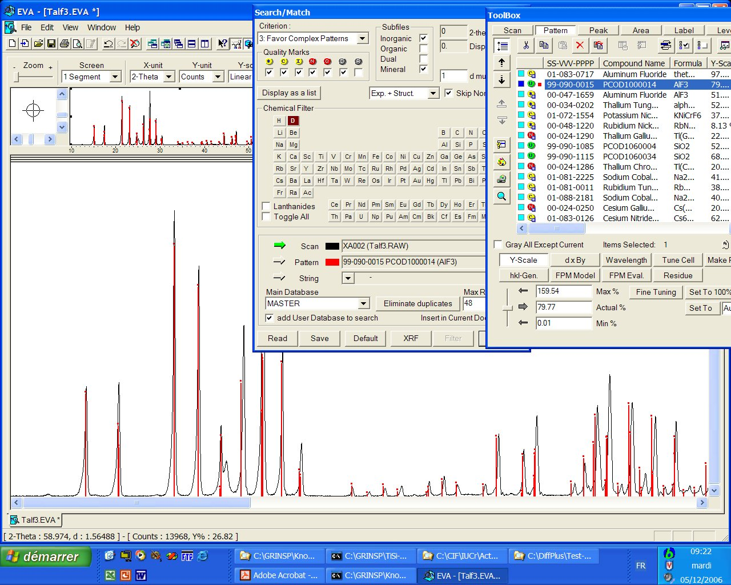
2- Correct formulation, more than 1% difference on one cell parameter
Quartz a = 4.912 c = 5.404
Prediction 4.965 5.375
Difference (%) 1.08 0.54

Global search (Master + PCOD, chemistry not imposed) :
real compound in first position, first virtual is in position 12

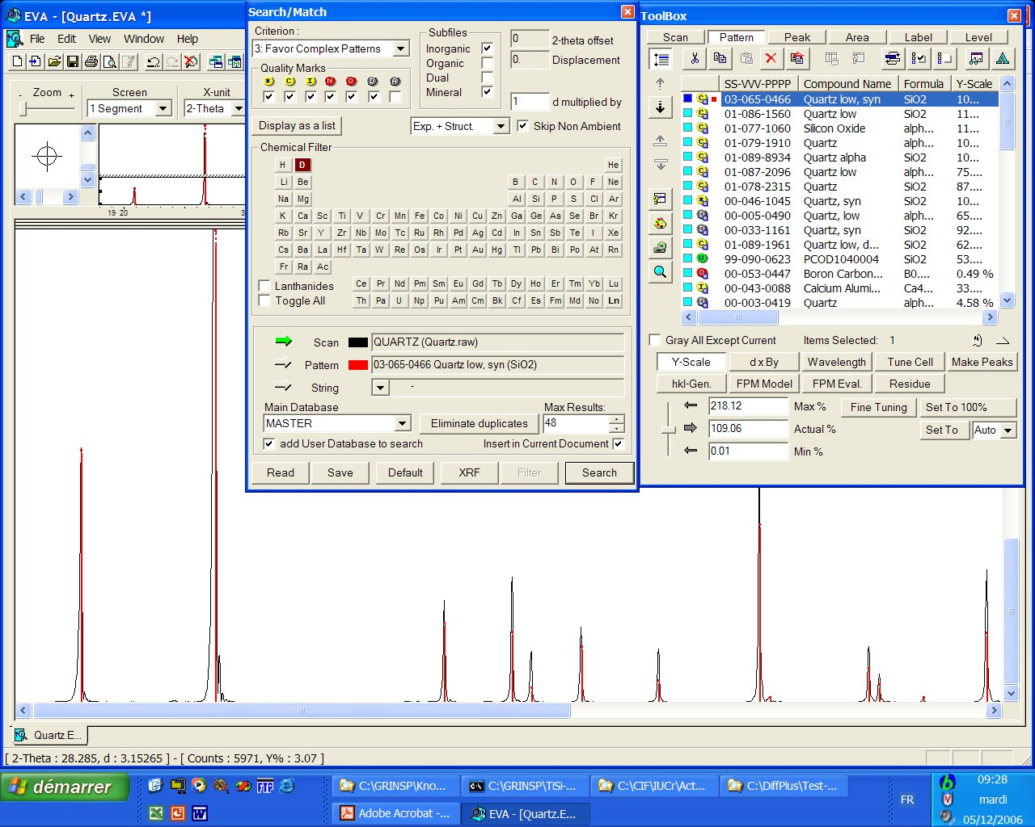

That PCOD model is very probably structurally derived from quartz,
however there is a superlattice :

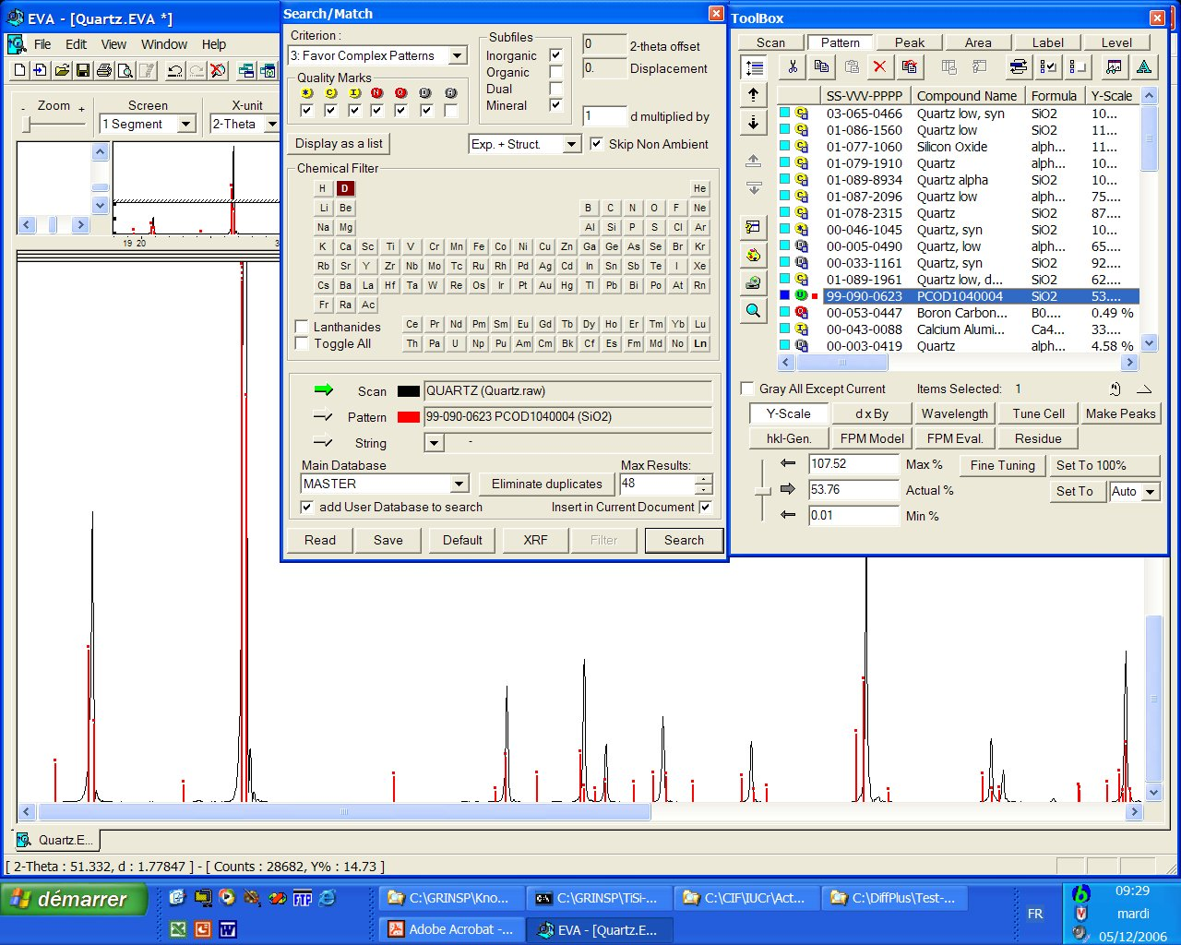

The PCOD model with the quartz structure is at position 40, showing strong discrepancies on the peak positions at large angles :

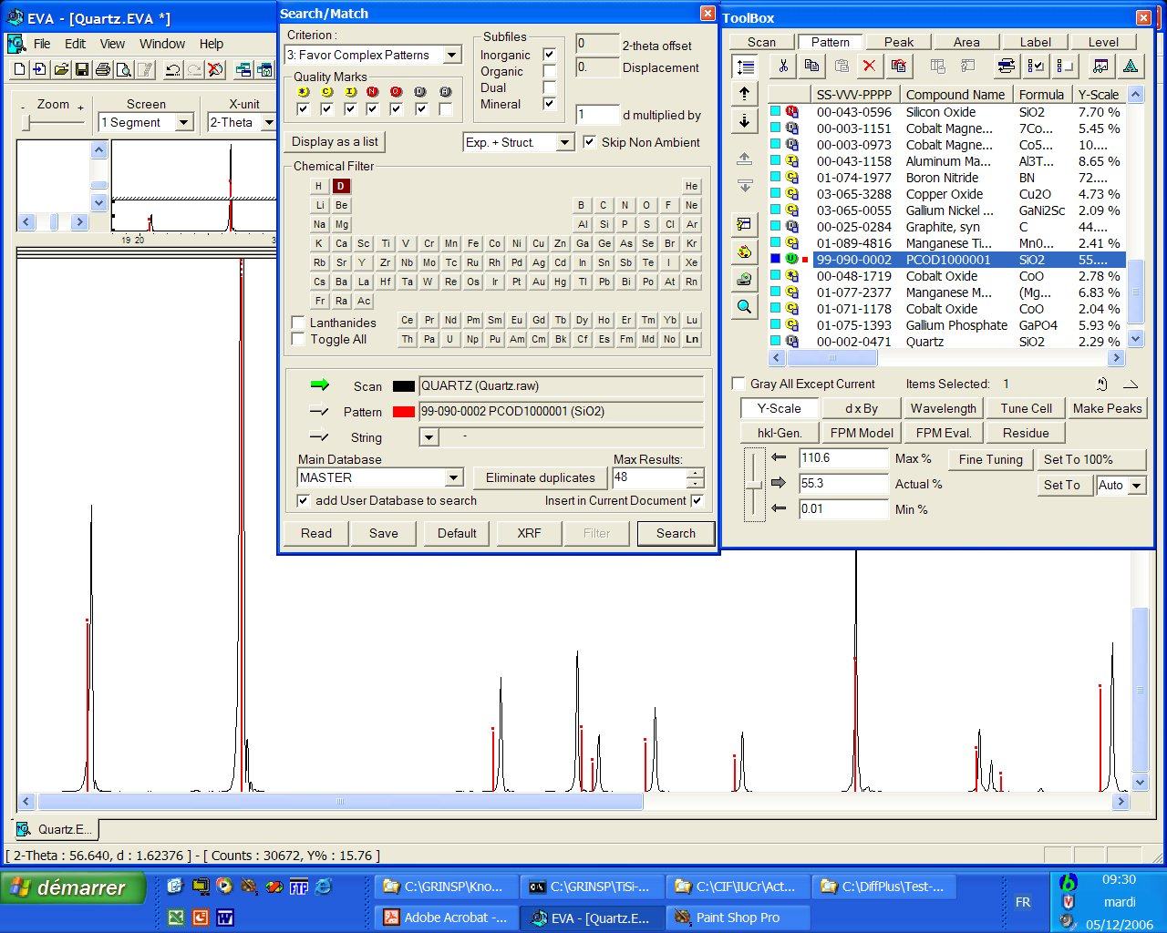

A more restrained search (chemistry : Si + O ; limitation to experimental diagrams)
gives the PCOD quartz in position 8 in the list :

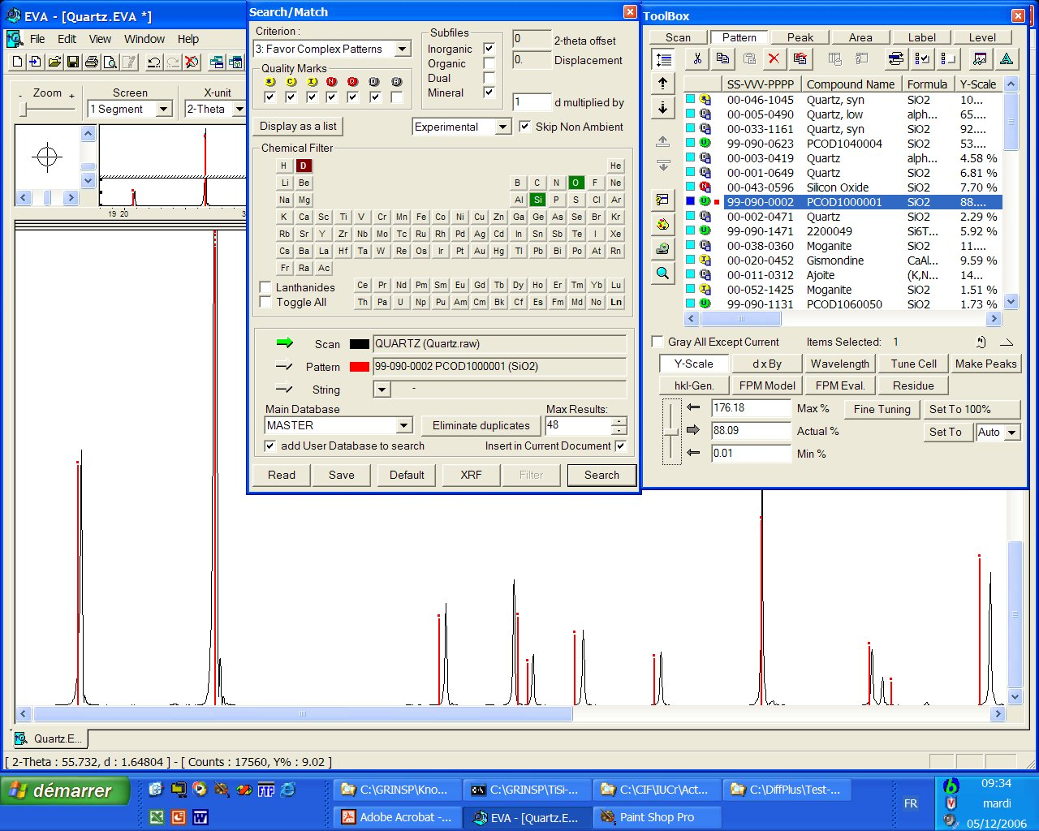

A bit illogical to declare the PCOD data as being “experimental” since they are virtual, but this is a small bug.

3– Incorrect chemistry, differences on cell parameters from 0.1 to 1.2 %
K₂TiSi₃O₉•H₂O a = 7.136 Å b = 9.908 Å c =12.941 Å
Prediction TiSi₃O₉ a = 7.22 Å b = 9.97 Å c =12.93 Å
Difference (%) 1.18 0.63 0.08

Global search (Mater + PCOD, chemistry not imposed) :
The real compound is at the first position, nothing from the PCOD.

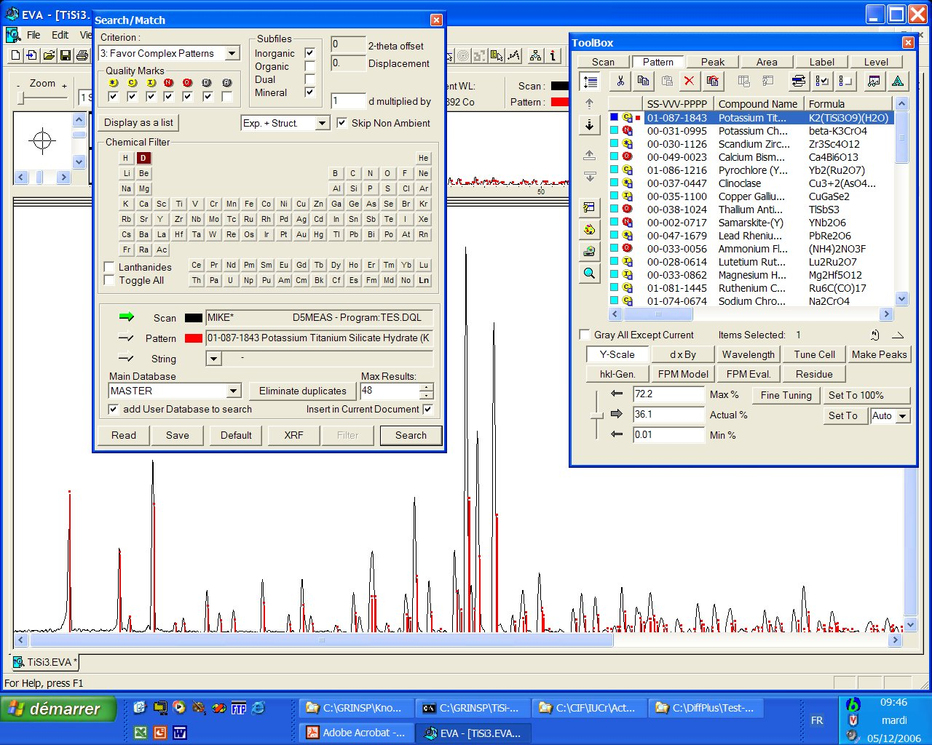

The correct virtual model appears in 2nd position if the chemistry Ti + Si + O is constrained, in spite of large disagreement on intensities (K and H₂O are lacking in the model) :

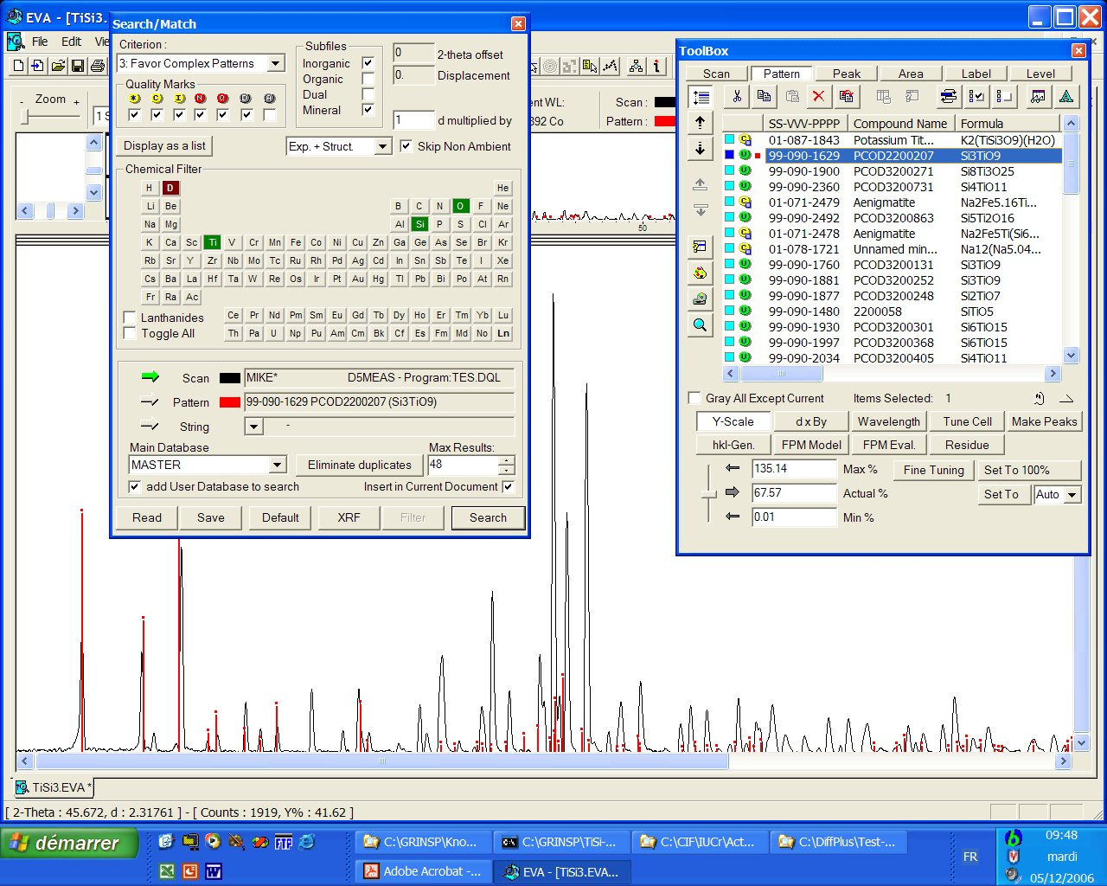

4- Incorrect chemistry, difference ~ 0.9 %
Na₄Ca₄Al₇F₃₃ cubic a = 10.781
Prédiction : Ca₄Al₇F₃₃ a = 10.876
Difference (%) 0.88

Chemistry-restrained search (Ca + Al +F), and Master + PCOD :
There are 4 PDF entries ahead, all being correct.
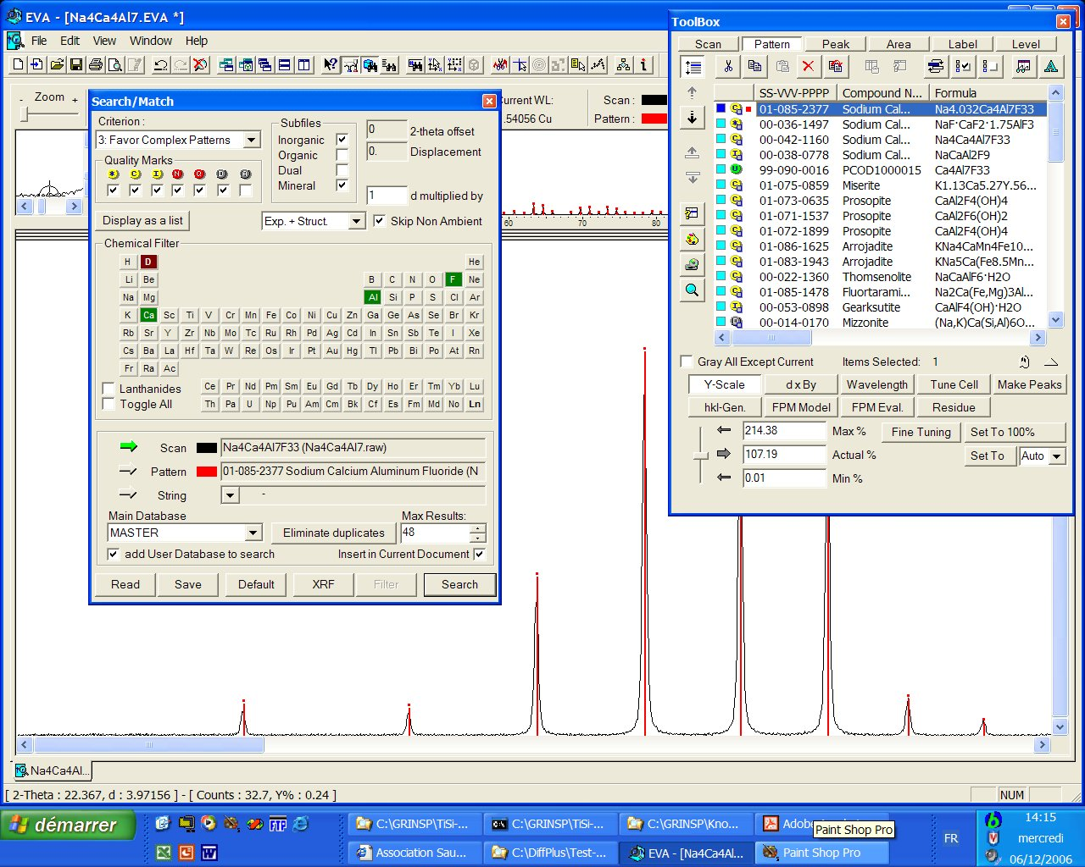

The PCOD entry comes in fiftt position
if the angular range for the search is restrained to less than 30°(2θ) :

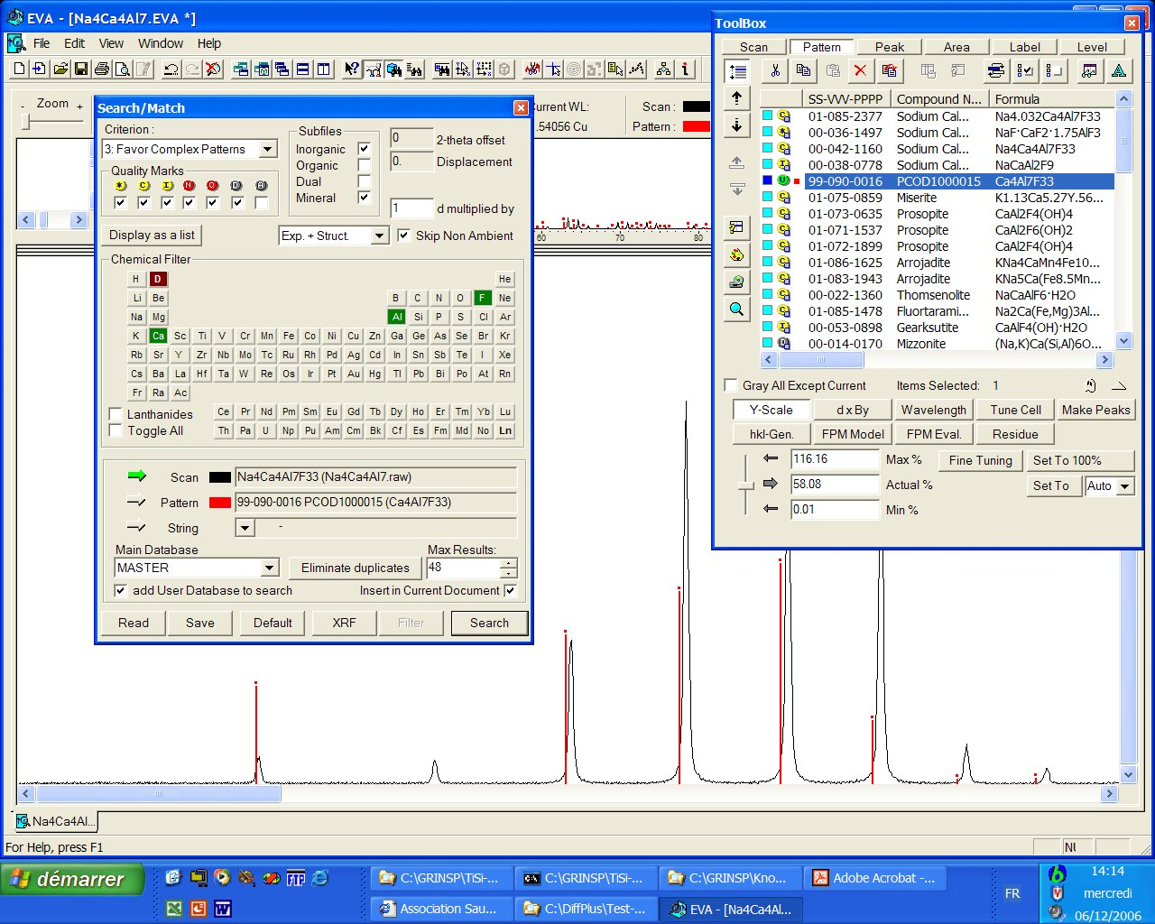

Conclusions :

Two main problems can obviously lead to failure in identification, and may even combine for disastrous effects (though not observed for these 4 cases where the discrepancies in cell parameters stay smaller than 1.2%) :

1 - Inaccuracies in the predicted cell parameters, playing on the peak positions
2 – Uncomplete chemistry of the PCOD models, influencing the peak intensities.

However, identification may succeed satisfyingly if the chemistry is restrained adequately during the search and if the differences in cell parameters is smaller than 1%.

Because cell parameter discrepancies have smaller effects at low diffracting angles, it is suggested to limit the maximum angle on the experimental diffraction pattern to 40 or even 30°(2θ) for increasing the chances of success.

The crystal structures of τ-AlF₃ and K₂TiSi₃O₉•H₂O were determined from powder data and published respectively in 1992 and 1997 (absence of suitable single crystals). Thanks to the P2D2 combined with a search-match software as EVA, these structures would have been determined directly at this preliminary identification stage, even before any indexing.

References

t-AlF₃: Crystal structure determination from X-ray powder diffraction data. A new MX₃ corner-sharing octahedra 3D network. A. Le Bail, J.L. Fourquet and U. Bentrup, J. Solid State Chem. 100, 151-159 (1992).

Structure of Zeolitic K₂TiSi₃O₉•H₂O Determined ab initio from Powder Diffraction Data. M.S. Dadachov and A. Le Bail, Eur. J. Solid State Inorg. Chem. 34, 381-390 (1997).

Results and conclusions of the internet based Search/Match Round Robin 2002, J-M. Le Meins, L.M.D. Cranswick, A. Le Bail, Powder Diffraction, 18 (2003) 106-113.

